Test Case ID: TC_WA_001

Test Summary: Verify that a user can send a text message on WhatsApp.

Test Steps:

1. Open WhatsApp Application:

- Launch the WhatsApp application on the device.

2. Log in to WhatsApp:

- Log in with a valid phone number and credentials.

3. Navigate to a Chat:

- Select an existing chat or start a new chat.

4. Type a Text Message:

- In the chat window, type a text message.

5. Send the Message:

- Click or tap the send button to send the text message.

Prerequisites:

- WhatsApp application installed on the device.

- Active internet connection.

- A user account in WhatsApp

Device: Android

Test Data:” hello user”

Expected/Intended Results:

- The text message should be sent successfully.

- The sent message should be displayed in the chat window.

- The recipient should receive the message promptly.

- No errors or unexpected behaviour should occur during the process.

Defect Analysis: Login Page Issues

High Severity Defect:

Defect ID: 001

Descriptive Defect Name and Type: Unauthorized access to landing page

Defect Severity: High

Defect Priority: High

Defect Status: Open

Detailed Description:

Steps to Reproduce:

Access the login page.

Leave the username and password fields empty.

Click the "Login" button.

Observe that the system allows access to the landing page without proper credentials.

Expected Result: Access should be denied without valid login credentials.

Screen Prints/Logs:

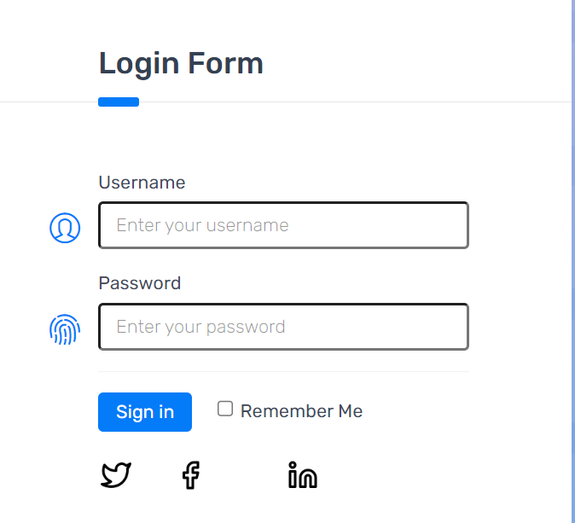

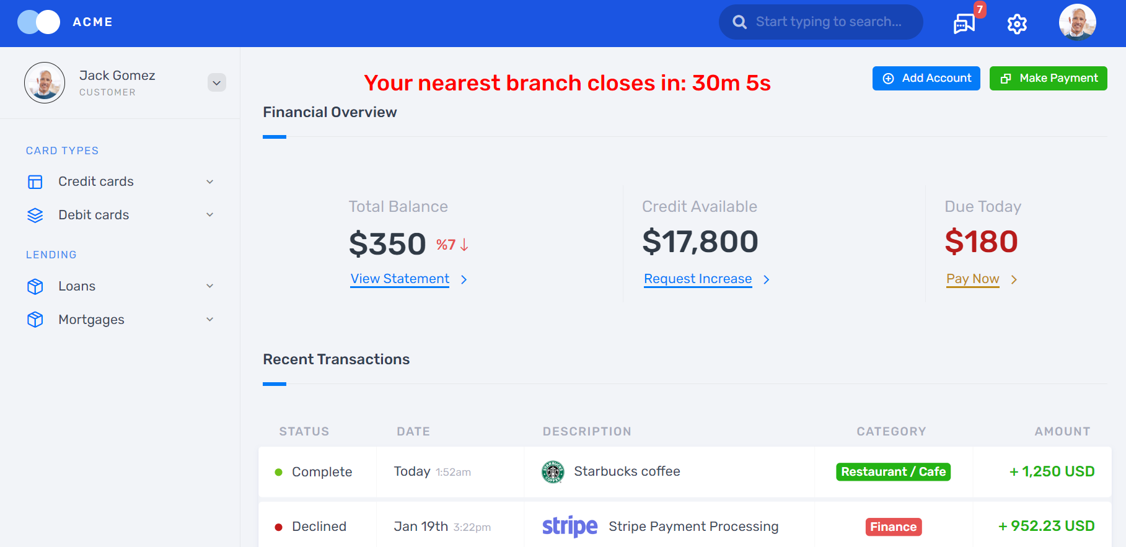

Medium Severity Defect:

Defect ID: 002

Descriptive Defect Name and Type: Non-functional features on the landing page

Defect Severity: Medium

Defect Priority: Medium

Defect Status: Open

Detailed Description:

Steps to Reproduce:

Log in to the system using valid credentials.

Navigate to the landing page.

Attempt to use various functionalities (e.g., buttons, links, forms).

Observe that none of the functionalities are responsive or working as expected.

Expected Result: Functionalities on the landing page should work as intended.

Screen Prints/Logs:

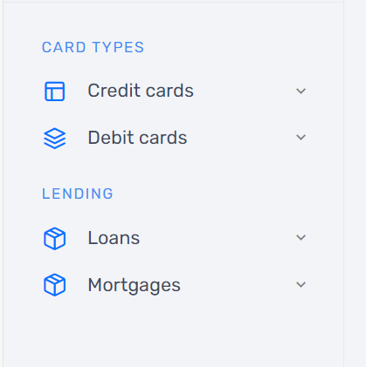

Low Severity Defect:

Defect ID: 003

Descriptive Defect Name and Type: timer is not working

Defect Severity: Low

Defect Priority: Low

Defect Status: Open

Detailed Description:

Steps to Reproduce:

Log in to the system using valid credentials.

Navigate to the landing page.

Review the timer for nearest branch closing time on the landing page.

Expected Result: The timer should work and the time should reduce.

Screen Prints/Logs:

